Εικόνα που περιέχει λογότυπο

Περιγραφή που δημιουργήθηκε αυτόματα

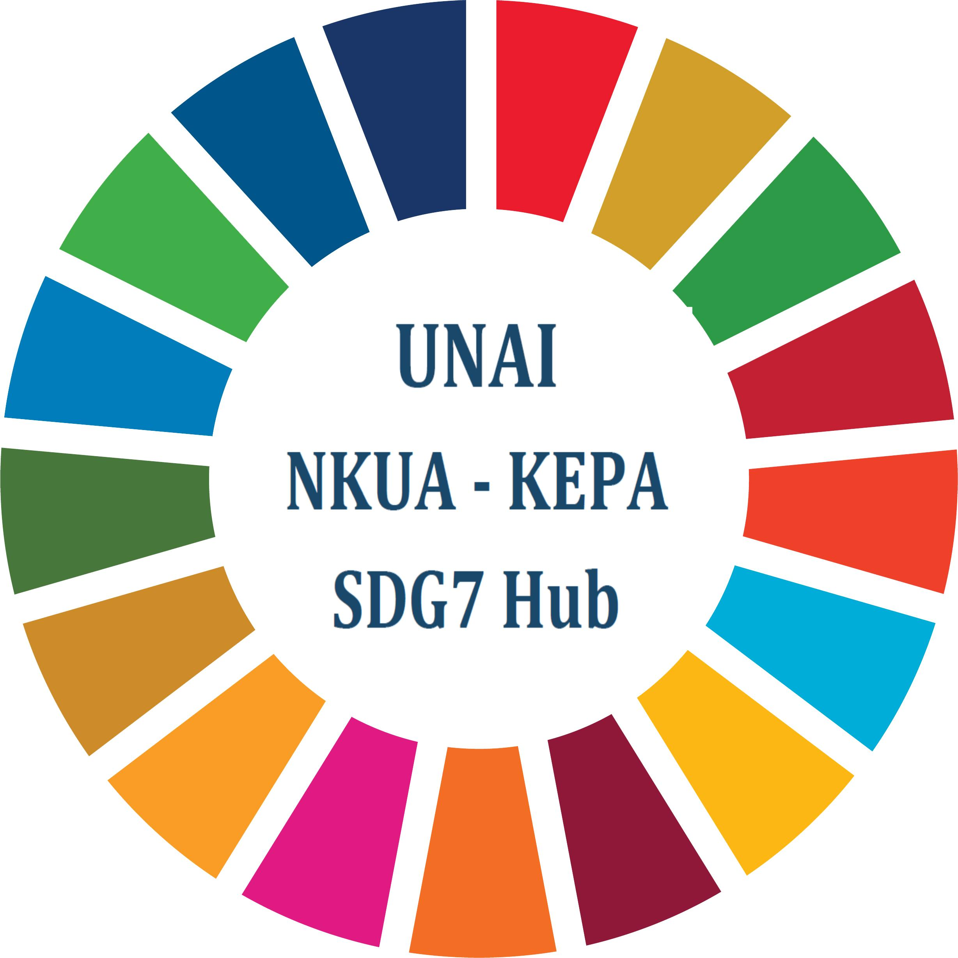

Εικόνα που περιέχει λογότυπο

Περιγραφή που δημιουργήθηκε αυτόματα



|  |  |  |  |  |  |  |  |
| --- | --- | --- | --- | --- | --- | --- | --- |
| ***Personal information*** | | | | | | | |
| Name: |  | | | | | Title: | |
| Organization: |  | | | | | | |
| Position: |  | | | | | | |
| Full Address  (incl. postal code, city, country): | |  | | | | | |
| Telephone: |  | | | Fax: |  | | |
| E-mail: |  | | | URL: |  | | |
| ***Registration categories*** | | | | | | | |
| Observer (academics, market stakeholders, corp diplomatic) | | | | | | |  |
| Attendee | | | | | | |  |
|  | | | | | | | |
| ***Preference to specific SDG (please quote in case of YES)*** | | | | | | | |
| Εικόνα που περιέχει λογότυπο  Περιγραφή που δημιουργήθηκε αυτόματα  UNAI__LOGO_E_SDG_Wheel_Letter_300ppp_HUB_SDG7_KEPA_21_April_2020_blue_skouro_olo | | | | | | | |
| YES |  | | NO | | |  | |

Note:

Observers are invited to participate:

1. At the round table discussions of the “Meeting” (7 Oct. 2024),

2. At the works of the Forum (9 Oct. 2024).

Short notes of one (1) page may also be disseminated to UNAI SDG Hubs, provided that they will be submitted to KEPA Secretariat in advance (epgsec@kepa.uoa.gr).